Oakfield Community

Primary School

School Uniform Policy

2022-2024

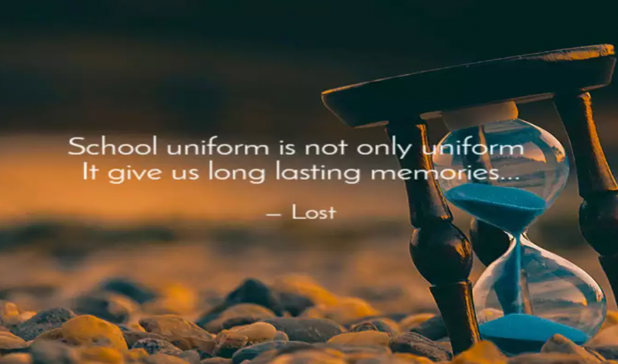

SCHOOL UNIFORM – WEAR IT WITH PRIDE!

This policy is based on advice from the Department for Education (DfE) and complies with the Human Rights Act 1998 and Equality Act 2010

Aims and Philosophy

As a school, we firmly believe that having a school uniform helps to promote the ethos of our school and provides a sense of belonging and identity to our pupils.
We believe that school uniform helps to promote positive attitudes and positive self – images and allows children to stand out for their efforts and talents and not what latest fashion items they have/have not got.

Key Updates

We have updated our School Uniform policy, so that all children from Year 1-6 can come to school dressed for the day. Therefore, if it is PE, they can come wearing their PE Kits and if they are in Forest School, they can wear suitable dark outdoor clothing. This enables us to maximize lesson time and get the most out of the day!

In EYFS, getting dressed is an important early learning goal, so they will practice this skill during the lesson and unless the teacher informs parents, children will always wear their school uniform.

On school trips, we will always let parents know what the dress is for the day. At times, it may not always be school uniform.

Children are also allowed to wear their own clothes during the day of their birthday or nearest day to it, if the day is in a holiday.

Stockists

Address: All uniform can be purchased from http://www.boydellswidnes.co.uk/
17 – 19 Victoria Road
Widnes
Cheshire
WA8 0PU
Phone: 0151 424 3257

We may also have some preloved school uniform, at a small cost, if you ask at the school office.

Our school uniform and what it looks like at Oakfield

GIRLS
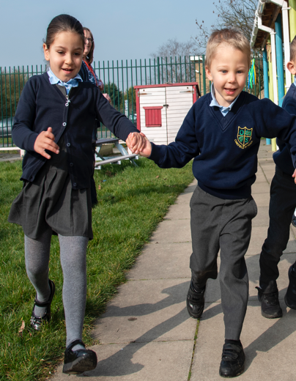
• Grey skirt, pinafore dress or trousers
• Blue and white gingham dress/Grey Shorts (summer)
• Blue polo shirt (EYFS/KS1) or pale blue shirt/ Blue polo shirt (Years 3/4/5) & White Shirt in Year 6.
•. A tie (clip on green with yellow stripe) must be worn with a shirt
• Blue sweatshirt or cardigan ideally with school logo
• Plain navy, grey or white tights or socks
• Black low-heeled shoes with no branding. NO training shoes
• Plain blue or blue and white gingham hair ties or headband
• Hair should be neat and tidy. Natural coloured and longer
-than-shoulder-length hair must be tied back.

BOYS
• Grey trousers/Grey Shorts (Summer)
• Blue polo shirt (EYFS/KS1) or pale blue shirt/ Blue polo shirt (Years 3/4/5) & White Shirt in Year 6.
• A tie (clip on green with yellow stripe) must be worn with a shirt
• Blue sweatshirt ideally with school logo
• Dark coloured socks
• Black shoes, no branding – NO training shoes
• Hair should be neat and tidy, natural coloured and no hair designs cut into shaved
hair. Longer-than-shoulder-length hair must be tied back.

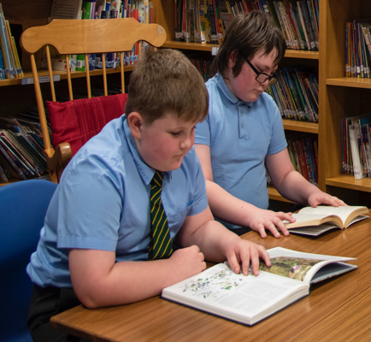

P.E. KIT
• Navy blue shorts or skirt
• White T-shirt with or without school logo
• Black pumps
• Trainers –for indoor and outdoor PE
• Grey or blue unbranded jogging bottoms and sweatshirt for outdoors, weather
appropriate.

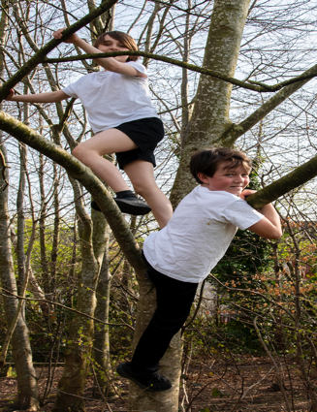
FOREST SCHOOL
•. Dark suitable outdoor clothing, weather appropriate

NURSERY AND RECEPTION
• School uniform - as above.
• Navy or black jogging bottoms are allowed to support children’s independence.
• PE Kit - as above.

Please note:
- We ask Nursery children to have a set of spare clothes in school, in the event of a child needing to be changed i.e., messy play or toileting support.

JEWELLERY
• Watches / activity trackers only (to be removed for all PE/games lessons)
• Stud earrings are to be worn only. If any child comes to school in hoops/dangly
earrings they will be asked to remove them)
- Necklaces and bracelets will all be removed and kept in a safe place if a child wears them and has forgotten to take them off.

Please remember:

- NO make-up, false nails, or nail varnish. Hair should not be coloured (Natural hair colour only)

- Please ensure ALL items of clothing and footwear are marked with your child’s name

Religion or beliefs

Some religions and beliefs require their members to conform to a particular dress code or to manifest their belief otherwise outwardly. This could include wearing or carrying specific religious artefacts, not cutting their hair, dressing modestly, or covering their head. Pupils have the right to manifest a religion or belief, but not necessarily at all times, places or in a particular manner.

Where school has good reason for restricting an individual’s freedoms, for example, the promotion of cohesion and good order in the school, or genuine health and safety or security considerations, the restriction of an individual’s rights to manifest their religion or belief may be justified.

As a school, we are sensitive to the needs of different cultures, races and religions and will act reasonably in accommodating these needs, without compromising our school policies, such as school safety or discipline, wherever possible.

The role of school staff
Staff will ensure this policy is consistently applied. They will liaise with parents to ensure that children wear the correct uniform and have all equipment they need for the day and the activities the children may be taking part in e.g., P.E. kits/Forest school kits/Swimming kits etc.

The role of the Headteacher
The Head teacher will ensure that this policy is adhered to by parents and children and will support staff in applying this policy.

The role of Parents

- The school collaborates actively with parents.
- Sign our Home/School Agreement, (along with their child) as a contract of agreement.

The role of Governors
- The Governing Body has the responsibility of setting down these general guidelines on standards of uniform. The Governors support the Headteacher and school staff in adhering to these guidelines.
- The Headteacher has the day-to-day authority to implement the school's policies, but Governors may give advice to the Headteacher about specific issues.

Monitoring and review
- The Headteacher monitors the effectiveness of this policy on a regular basis. She also reports to the governing body on the effectiveness of the policy and, if necessary, makes recommendations for further improvements.

