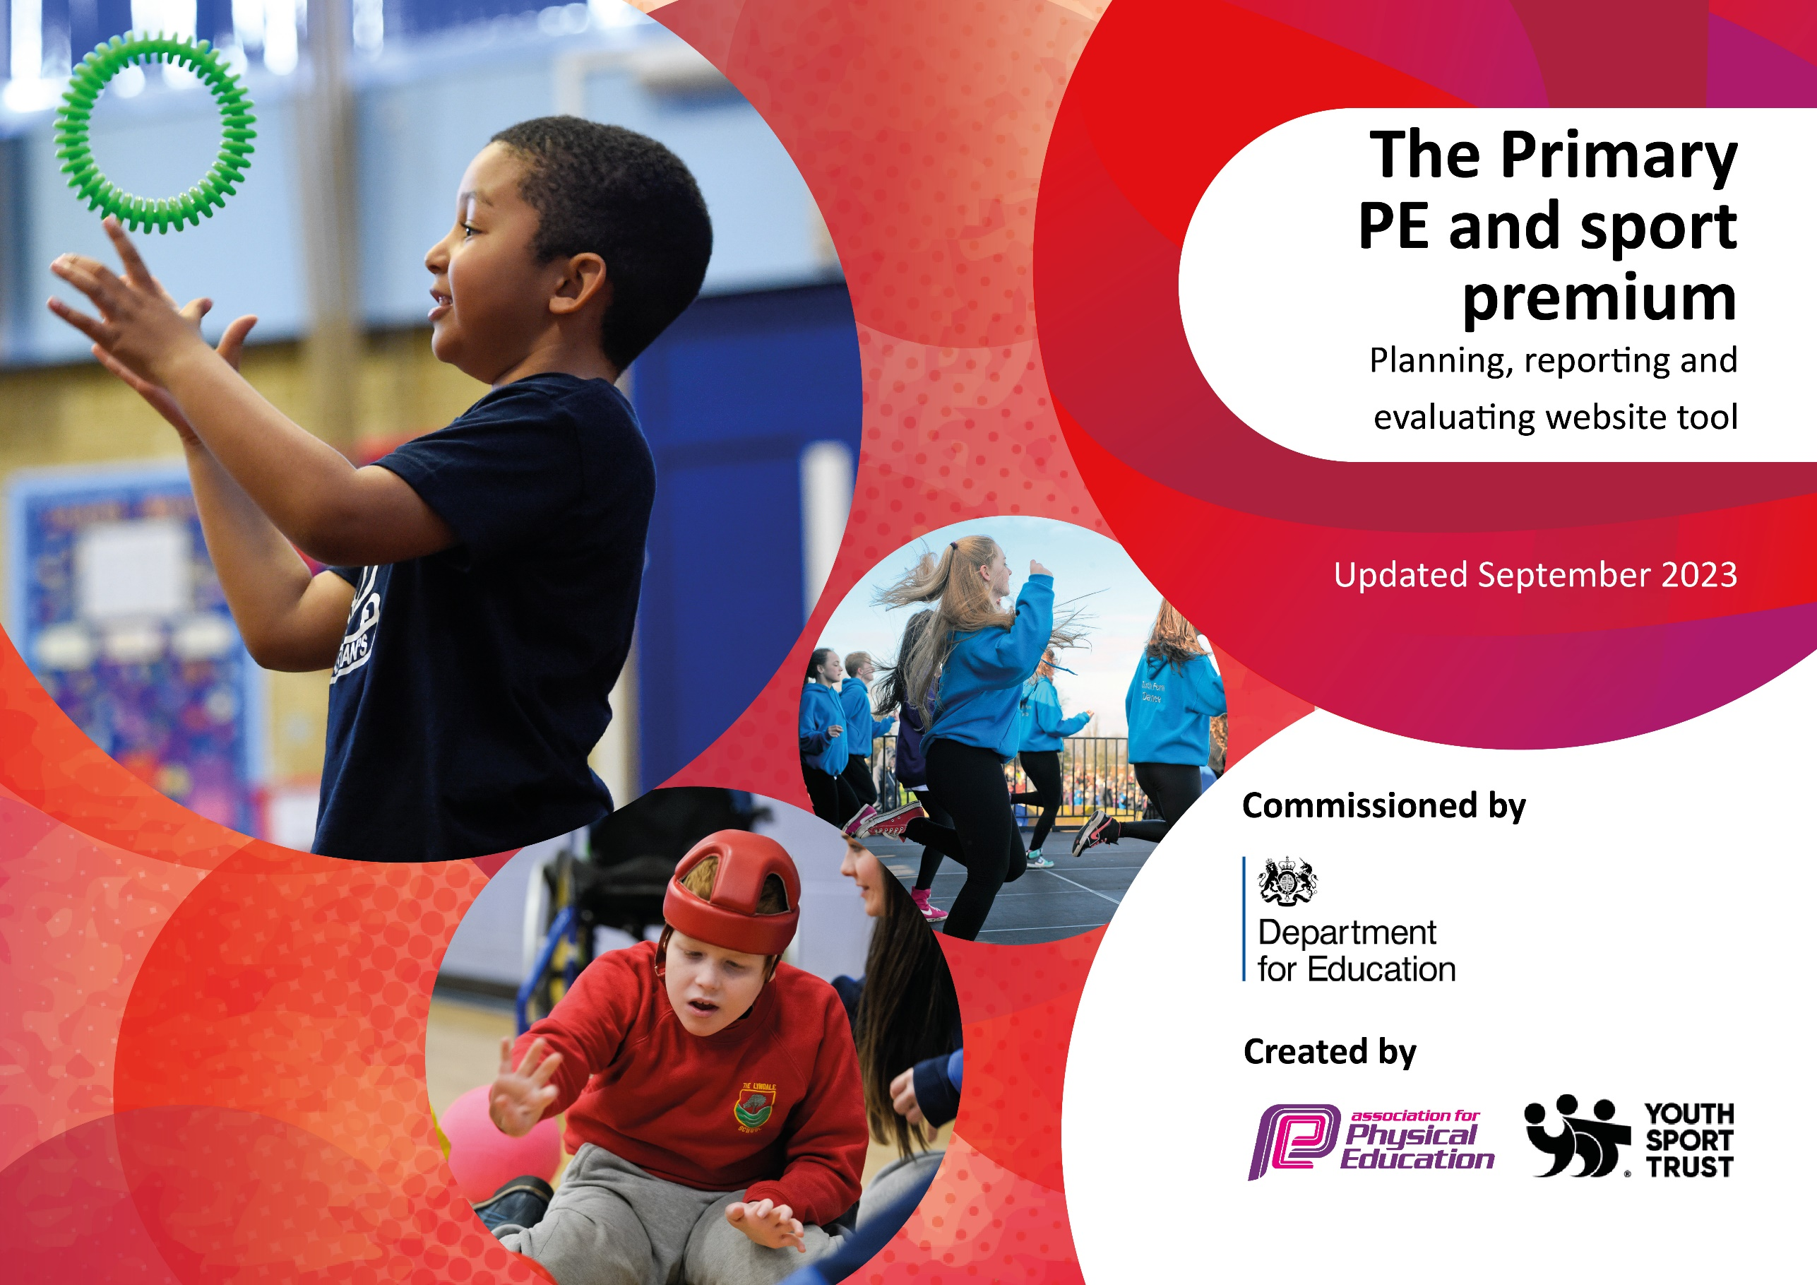

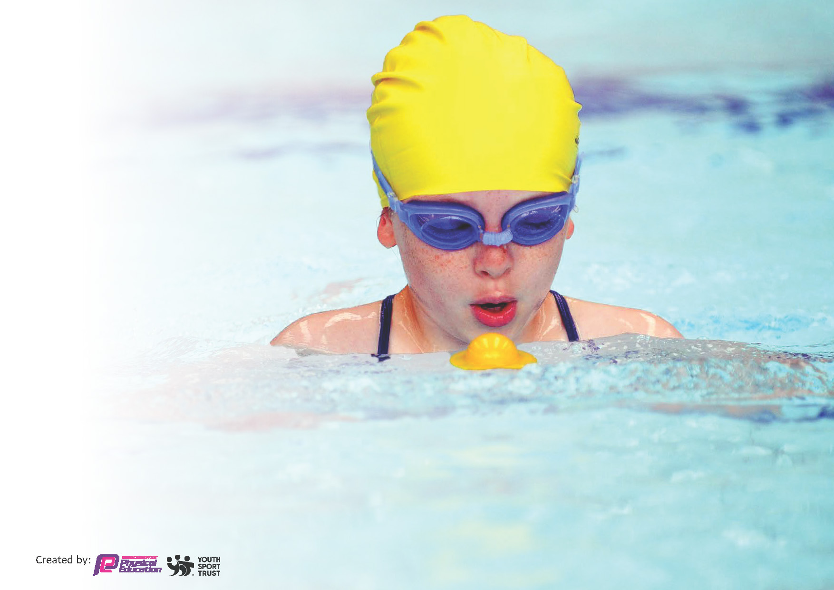
This template can be used for multiple purposes:
by:
- It enables schools to effectively plan their use of the Primary PE and sport premium
- It helps schools to meet the requirements (as set out in guidance) to publish information on their Primary PE and sport premium
- It will be an effective document to support Ofsted inspections enabling schools to evidence progress in Physical Education (PE) and evidence swimming attainment, which forms part of the PE National Curriculum. We would recommend schools consider
the Intent, Implementation and Impact of any spend, as examined within the Education Inspection Framework.

It is important that your grant is used effectively and based on school need.

Schools must use the funding to make additional and sustainable
improvements to the quality of the PE, School Sport and Physical Activity (PESSPA)
they offer. This means that you should use the Primary PE and sport premium to:

- Build capacity and capability within the school to ensure that improvements made now will benefit pupils joining the school in future years
- Develop or add to the PESSPA activities that your school already offers.

The Primary PE and sport premium should not be used to fund capital spend projects; the school’s core budget should fund these. Further detail on capital expenditure can be found in the updated Primary PE and sport premium guidance.

The Primary PE and sport premium guidance, outlines 5 key priorities that funding should be used towards. It is not

necessary that spending has to meet all the key priorities, you should select the priorities that you aim to use any funding towards.

Although completing this template is not a requirement for schools, schools are required to publish details of how they spend this funding. Schools must also outline what the impact this funding has had on pupils’ PE and sport participation and attainment and how any spending will be sustainable in the future. All funding must be spent by 31st July 2024.

The Department for Education has worked closely with the Association for Physical Education (afPE) and the Youth Sport Trust (YST) to develop this template and encourages schools to use it. This template is an effective way of meeting the reporting requirements of the Primary PE and sport premium.
Review of last year’s spend and key achievements (2024/2025)

We recommend you start by reflecting on the impact of current provision and reviewing your previous spend.

Activity/Action | Impact | Comments
Widnes Viking school partnership subscription Covers Summer 24/Autumn 24/ Spring 25 terms.  Inter/Intra competitions for football on new Muga pitches, which are also supported by after school clubs  Swimming Lessons- pop up pool for lessons on site over 3 weeks. | The children will have access to curriculum time sessions, the staff from the Vikings work alongside staff to deliver sessions based on their PE planning. Often key skills in rugby are taught through the delivery of rugby-based sessions which aren’t always evident in curriculum lessons.  All chn are rotated round at lunchtimes to allow max access to football pitches and competitions are set up between classes and local schools. An after-school club has provided additional coaching and set expectations that support lunchtime behaviour.  All chn in Y4,5,6 swim daily and have a small based session which is more personalized and meaningful to their individual needs. Lessons are also delivered to our SEND Resource Base pupils, and they have 1;1 support in the pool as well. We have seen a massive increase in the number of pupils who attain the national expectations and overcome fears of water with this approach. Additional coaching is offered for those chn to ensure they also meet the required national standards. BothY3 classes were able to enjoy taster sessions to prepare them for swimming next year. | Chn love the enthusiasm and energy that a professional coach provides.  The partnership has also provided opportunities for children and families to attend games at the stadium.  The increase in activity and group participation among both boys and girls has increased massively with the pitches. We have seen not only the impact on activity but also on social skills.  As part of England Football’s Biggest Ever Football Session, all year groups took part in football activities using the pitches. Responding to the ‘pupil voice’ we allocated some girl only pitches during break times. Such was the uptake that we have continued this since.  Daily swimming supports skills and individual development more rapidly. As there are small gps of chn in the pool the teaching is centred around their needs and the chn get a greater level of teaching.  There is also less loss learning time with no travel time.

Key priorities and Planning
This planning template will allow schools to accurately plan their spending.

Action – what are you planning to do | Who does this action impact? | Key indicator to meet | Impacts and how sustainability will be achieved? | Cost linked to the action
Ensure that we have the equipment to enable us to perform lessons safely. We have aimed to increase the amount and quality of equipment we are able to offer, so the amount of time waiting to ’have a go’ is reduced. We also aim to provide additional equipment to support structured playtimes / lunchtimes.  Utilise Lunchtime Play sessions to encourage creativity and develop self-regulated play.  Promote and rotate use of gym equipment to encourage an active lifestyle  Promote and rotate use of Muga pitches to engage pupils in team sports  Swimming Lessons for Y4,5,6 and all SEND pupils, onsite in a pop-up pool. | New equipment ordered to make sure that lessons adhere to government guidelines. During lessons children spend more time being active. Positive outcomes are greater levels of activity and reduced behaviour issues. Similarly, chn have choices as to how they play at unstructured times which also impacts positively on their behaviour.  Outdoor activities/ new equipment offered in a quiet zone which develop social skills as well as physical development  All pupils in KS2 will have regular access to stationary gym equipment (walkers/steppers) and will engage in circuit training.  All pupils in KS2 will have regular access to Muga pitches to develop football and ball skills.  These onsite sessions allow a highly personalized approach to meet the needs of the group. Additional sessions offered for chn who may not achieve the national expectation. | Key indicator 1: The engagement of all pupils in regular physical activity – Chief Medical Officers guidelines recommend that primary school pupils undertake at least 30 minutes of physical activity a day in school | Lessons are able to be taught keeping children and staff without losing the impact of lessons on learning. Unstructured times are less disruptive and chn have choices which engage them physically and develop SEMH skills.  Pupils will confidently engage in activities at playtimes using equipment effectively.  Promote the use of ‘gym’ equipment that will support a healthy lifestyle for the future.  Increase the number of girls participating in team sports.  To support chn achieving the National expectations and help some pupils overcome their fear of water.

Maintaining the high profile for PEPSA by hiring specialist P.E. practitioners which encourages pupils and teachers to engage in healthy lifestyles.  Widnes Viking professional coach teaches rugby skills.  Participate in the ‘Chance to Shine’ whole school programme ran by the Cheshire Cricket Company  Raising teacher competencies in P.E. via high quality professional development leading to high quality lesson delivery.  Increase staff confidence teaching PE  Develop PE subject Lead and ensure quality Leadership time  Develop accurate and meaningful assessment of PE skills  Offer of high quality after school clubs run by specialists / teachers  Wider opportunities for pupils – visit high-profile sporting events  To maintain the high volume of pupils attending enrichment activity and inter-school competition – e.g. Widnes inter-school competitions /School Games/local schools. | Work with Widnes Vikings to provide high quality sessions and raise the profile of the local Widnes Vikings Team. Coaching staff from the Vikings have been able to direct children to local youth teams.  Chn have an experienced coach and our partnership also allows them to watch the Vikings with their family with free tickets.  Participation and collaboration with events across the year, enabling wider school competitions and access to ‘other sports’.  Developing 4 key skills:  Run on Respect  Embrace Enjoyment  Build Belonging  Progress with Purpose  Bespoke CPD packages for staff and networking with other PE specialists to develop increased expertise in the area of teaching and leading P.E  Teachers to understand and use the scheme to increase confidence teaching and assessing PE  Monitor and quality assure teaching of PE, allowing for high quality feedback and subject development  Develop use of See saw to assess PE skills  Cheshire Cricket Club after school club to further enahnce skills taught in currciulum lessons  Gather pupil voice on their opinions of after school clubs  Offer of free tickets to Widnes Vikings matches as part of our partnership with the club  Increasing opportunity via attendance at inter-school competition.  Bus hire for attending.  Supply cover to free travelling staff. Membership fees, affiliation and entry fees to a range of competitions and events.  Increased opportunity will improve pupils’ motivation and social interaction thus having an impact on children’s academic achievement. | Key indicator 2: The profile of PESSPA being raised across the school as a tool for whole school improvement  Key indicator 3: Increased confidence, knowledge and skills of all staff in teaching PE and sport  Key indicator 4: Broader experience of a range of sports and activities offered to all pupils  Key indicator 5: Increased participation in competitive sport | Raised quality of teaching, learning and assessment resulting in high levels of pupil engagement.  This is an on going partnership and chn have been developing their skills over their time at school.  Raised quality of teaching, learning and assessment resulting in high levels of pupil engagement in a different sporting activity.  CPD that raises the staff confidence levels. Develop further CPD programme for all staff, including MDAs and TAs  Deep Dive evidence improvements to the quality of education. New curriculum teams to plan out further CPD sessions as part of their inset.  Staff are more confident and knowledgeable in the delivery of PE curriculum – evidence from staff voice. Assessment of PE will become a strength in school  Wide range of clubs offered and increase uptake on after school clubs.  Children to gather interest and a love of sport / local area and staying active. Further visits to high quality sporting events.  Large proportion of children having opportunities to participate in inter-school sporting activity.  Develop inter/intra competitions and network with local primaries within walking distance. | .

Swimming Data
Meeting National Curriculum requirements for swimming and water safety.
Priority should always be given to ensuring that pupils can perform safe self-rescue even if they do not fully meet the first two requirements of the National Curriculum programme of study

Question | Stats: | Further context  Relative to local challenges
What percentage of your current Year 6 cohort can swim competently, confidently and proficiently over a distance of at least 25 metres? | 80% | Due to the distance travelling to the local pool we have an onsite pop-up pool for 3 weeks in the summer term. This allows all pupils in Y4,5,6 to swim every day. Many of our chn have not been in a pool beforehand and have limited life experiences. Overcoming the fear of water and having the confidence to get into the pool can be the biggest challenge.
What percentage of your current Year 6 cohort can use a range of strokes effectively [for example, front crawl, backstroke, and breaststroke]? | 80% | The pop-up pool allows chn to have personalized sessions in smaller groups and in the smaller setting there is less disruption.

What percentage of your current Year 6 cohort are able to perform safe self-rescue in different water-based situations? | 80% | All skills taught accordingly and appropriately to the ability of each group. Chn make rapid progress as lessons are highly focused and structured.
If your schools swimming data is below national expectation, you can choose to use the Primary PE and sport premium to provide additional top-up sessions for those pupils that did not meet National Curriculum  requirements after the completion of core lessons. Have you done this? | Yes/No | With the pool onsite chn swim daily and additional session are offered to chn before/after school to ‘catch up’.
Have you provided CPD to improve the knowledge and confidence of staff to be able to teach swimming and water safety? | Yes/No | The teachers are alongside the experienced swimming instructor and support. Where needed a teacher will go into the water to support pupils, especially with SEND .

Signed off by:

Head Teacher: | Mrs Makin
Subject Leader or the individual responsible for the Primary PE and sport premium: | Mr Carson
Governor: | Mr Green
Date: | 1st Sept 2025

Expenditure Spend:

Schools Games Programme | £495
Vikings Rugby | £2,280
Cheshire Cricket Club | £960
Additional Swimming costs | £2,500
Gym Equipment/ Playground circuit markings | £12,695 ( £6,347.50 offset over 2 years )
2 Recess end goals | £3,800 (£1,900 offset over 2 years)
Playground/sports equipment | £1,000
Staff Release time/CPD | £2,200
Transport for competitions | £1500
Total Sports Premium | £18,300

